Introduction
Non-restorative sleep (NRS) is a condition characterised by subjectively unrefreshing sleep despite normal objectively measured sleep duration and architecture, leading to excessive daytime fatigue, sleepiness, and diminished quality of life (Roth et al., 2010). Despite the impact of this condition, there are no established guidelines for diagnosis or clinical management, and it is not included in the Diagnostic and Statistical Manual-5-TR (DSM-5-TR) (American Psychiatric Association, 2022). NRS has previously been clinically managed as a subtype of insomnia disorder (ID) despite patients not exhibiting the symptoms associated with ID difficulty falling asleep, frequent arousals, and shortened sleep duration (Roth et al., 2010). ID has received significant attention and research due to being the most common sleep disorder in Australia and associated health burden, being linked to an increased risk of physical and mental health disorders, and decreased quality of life (Kyle et al., 2010; Sweetman et al., 2021). In contrast, NRS is poorly understood and treated, leading to X, Y, and Z. Currently, NRS symptoms are predominantly measured through subjective complaints, and it is unclear if the condition is associated with measurable changes to brain activity. If there are measurable changes in brain activity, this could aid in diagnosis (can I say diagnosed if it’s not a disorder?), treatment, and provide a greater understanding of the aetiology of the condition.
Both NRS and ID have been consistently associated with increased daytime fatigue, however findings on subjective and objective daytime sleepiness are inconsistent. While fatigue is a broad construct that refers to feelings of exhaustion or low motivation, sleepiness specifically refers to an individual’s sleep propensity, or their drive to sleep (Gradisar et al., 2007). Subjective sleepiness, being an individual’s self-assessed perception of their sleep drive at a given moment, and objective sleepiness, being the level of sleep-like brain activity recorded through electroencephalogram (EEG), are correlated and increase in response to prolonged wakefulness and reduce with sleep in healthy populations (Åkerstedt & Gillberg, 1990). EEG recordings provide a spatiotemporally integrated recording of neuronal signals across the cortical surface, allowing for the non-invasive measurement of brain activity and mental states in humans (Buzsáki et al., 2012). Although ID has been associated with decreased subjective and objective measures measures of sleepiness, it is not known how sleepiness manifests in an NRS population (cite).
Quantitative analysis of brain activity using high-definition electroencephalography (HD-EEG) data provides a novel way to explore daytime sleepiness in these populations. HD-EEG enables exploration of cortical activity variations across brain regions with greater spatial resolution than traditional EEG, allowing for neural measures of sleepiness to occur with localised variance across the brain. As sleepiness is a locally regulated phenomenon, …
This study will use HD-EEG data to examine if there are differences in subjective or objective sleepiness upon awakening between NRS in comparison to ID and healthy controls.

Sleep disorders

Insomnia disorder
ID is the most common sleep disorder in Australia with an estimated prevalence of 23.2% (Appleton et al., 2022). It is linked to detrimental outcomes for individuals, including increased risk of comorbid psychiatric disorders, reduced physical health, diminished quality of life, and significant daytime fatigue (Kim et al., 2019; Kyle et al., 2010; Morin et al., 2015; Perlis et al., 2022). ID is diagnosed through subjective reports of impaired overnight sleep, difficulty with sleep initiation, or frequent overnight arousals, leading to clinically significant distress or dysfunction in daily life (American Psychiatric Association, 2022).
The gold standard for diagnosis in most sleep disorders is polysomnography (PSG), being the overnight recording of EEG, cardiac, respiratory, and movement activity (Berry et al., 2017). However, ID is recommended to be diagnosed through subjective self-reports, as individuals with ID do not consistently display disruptions in objectively measured sleep microarchitecture ((American Academy of Sleep Medicine, 2005). While some individuals with ID have an objectively shortened sleep duration of less than 6 hours, others report subjective self-reported perceptions of shortened sleep or overnight awakening despite objectively normal sleep duration as measured by PSG, suggesting distinct subtypes of the disorder (Kao et al., 2021). However, recent research suggests that discrepancies between subjective and objectively recorded sleep may be due to mismeasurement of sleep using traditional PSG analysis, rather than subjective misperception of the sleep and wake state by the individual (Stephan & Siclari, 2023). So what? Therefore…
Non-restorative sleep
NRS is distinct from ID as the primary complaint is unrefreshing sleep despite normal sleep duration of 7-8 hours, and no subjective reports of difficulty initiating or maintaining sleep, or early morning awakenings (Roth et al., 2010). Daytime impairments associated with NRS include significant daytime fatigue, reduced cognitive performance, and reduced psychological well-being, leading to reduced quality of life and impaired daily function (Roth et al., 2010). The symptom of unrefreshing sleep upon awakening in Australia is estimated to be between 42-45%, however rates of treatment are only approximately 10% (Adams et al., 2017; Metse & Bowman, 2020). Despite the effects of the condition, it was removed as a characteristic of ID with the release of the Diagnostic and Statistical Manual-5 (DSM-5), resulting in this population being diagnosed as “other specified insomnia disorder”, with no guidelines for diagnosis or treatment (American Psychiatric Association, 2013). As NRS may be its own unique disorder with an underlying neurobiological cause, it is essential to develop diagnostic criteria and understand the associated etiology to improve outcomes for patients.

Sleep
Sleep is a necessary behaviour for all humans that can be defined as a reversible reduction in responsiveness to external stimuli accompanied by a measurable change in brain activity patterns (Cirelli & Tononi, 2008). Sleep progresses through a series of stages throughout the night, including rapid eye movement (REM) sleep and non-rapid eye movement (NREM) sleep, which is further divided into stages N1, N2, and N3, each distinguishable through distinct patterns of brain activity and muscle tone. Sleep is regulated by two systems, with the circadian system operating as a pacemaker that entrains the body to a 24-hour cycle in response to the external environment, while the homeostatic system increases sleep pressure, being the biological drive for sleep that increases in response to wakefulness (Borbély, 1982).
Sleep pressure can only be dissipated with sleep, with reduced sleep pressure measurable through the prevalence of slow wave activity (SWA) in the EEG. Slow waves are synchronized oscillations of membrane potential between hyperpolarised and depolarised states in the delta frequency range (0.5-4 Hz) that propagate throughout the brain in an antero-posterior cortical progression, with the greatest prevalence in N3 sleep (Achermann & Borbély, 2003; Riedner et al., 2007). Increased sleep pressure leads to greater SWA during sleep, with longer periods of hyperpolarization and greater synchrony between brain regions which reduce as sleep pressure dissipates (Vyazovskiy et al., 2011). Additionally, SWA has topographic variations throughout the brain, occurring locally and asynchronously across brain regions and most prominently in areas associated with increased activity during wake, suggesting sleep homeostasis is a locally regulated phenomenon (Krueger et al., 2019; Siclari & Tononi, 2017).
Sleepiness
Subjective sleepiness
Increased sleep pressure is perceived subjectively as sleepiness, which is hypothesized to act as a primary motivational drive ensuring organisms sleep regularly despite the risks arising from reduced consciousness (Axelsson et al., 2020). It is a measure of an individual’s self-assessed level of sleep pressure, objective drowsiness, or sleep propensity, which fluctuates throughout the day in response to the influence of sleep homeostasis and circadian systems (Åkerstedt et al., 2014). Subjective sleepiness can be measured as either trait or state sleepiness, with trait sleepiness being an individual’s propensity to fall asleep in a given situation, and state sleepiness being a measure of sleepiness at a point in time (Åkerstedt et al., 2014; Johns, 1991). State sleepiness is most commonly measured using the Karolinska Sleepiness Scale (KSS), a one item nine-point Likert scale correlated with EEG measures of drowsiness in healthy populations (Cluydts et al., 2002; Kaida et al., 2006).
Excessive daytime sleepiness is one of the most common complaints associated with NRS but is inconsistently observed in ID (Hein et al., 2017; Sarsour et al., 2010). Although daytime fatigue is the most prevalent and detrimental complaint observed in ID, the inability to sleep that is characteristic of ID means that subjective sleepiness may not be a sensitive measure of daytime sleepiness in this population (Kyle et al., 2010; Raizen et al., 2023). Therefore, there is a critical need for improved measurement tools that can capture the experiences of ID and NRS.
Objective sleepiness
Objective sleepiness refers to the quantifiable level of sleep pressure within an individual measurable through neurophysiological measures. Outline here why KDT
Increased sleep pressure, such as that occurs as a consequence of experimentally manipulated sleep deprivation, can be observed through a shift of EEG spectral power from fast frequency activity in the alpha (8-12 Hz), gamma (13-35 Hz) and beta (15-25 Hz) frequencies to slower frequency activity in the delta and theta (4.5-8 Hz) frequencies [@cite]. This shift is most prominent in theta power, with increased theta oscillations during eyes-open (EO) resting wake mirroring the predicted trajectory of sleep pressure (Snipes et al., 2023). Additionally, this increases occurs in a task-dependent manner with localised variance, mirroring the process observed in sleep deprivation and subsequent recovery SWA during sleep [@cite]. Theta activity reflects fluctuations in circadian rhythms, decreases following caffeine consumption, and is increased in individuals suffering from excessive daytime sleepiness (EDS), meaning it appears to be a marker of sleepiness, rather than just sleep pressure (Aeschbach et al., 1997; Landolt et al., 1995; Melia et al., 2015). However, as theta activity is also associated with fatigue, increasing with time-on-task independent of changes in other frequency bands, it is insufficient as a measure of objective sleepiness alone (Li et al., 2020; Tran et al., 2020).
The increase in theta and shift from fast-frequency to slow-frequency EEG activity can be quantified as a slowing ratio (SR), which measures the ratio of fast frequencies to slow frequencies. SR is associated with reduced sleep onset latency, impairments to behavioural performance following sleep deprivation, and can be used to assess treatment effectiveness in obstructive sleep apnoea (Appleton et al., 2022; Gibbings et al., 2022; Tracey et al., 2024). Both wake and sleep. Although this measure is commonly used to measure sleepiness, it does not consider that alpha power manifests differently with increasing sleepiness when the eyes are open vs eyes closed.
Under conditions of low sleepiness, alpha power is most prominent during eyes closed (EC) resting wake EEG recordings, with the greatest power in the occipital region. However, with increasing sleep pressure, alpha oscillations appear in EO resting wake EEG and attenuate when the eyes are closed [@cite]. Increased EO alpha power is correlated with increased sleep pressure accumulated through sleep deprivation and changes in body temperature occurring in response to circadian influences (Cajochen et al., 2002; Tian et al., 2018). Additionally, decreased EC alpha power represents the beginnings of sleep onset, representing the transition between wake and n1 sleep. This change in spectral power can be quantified as the alpha attenuation coefficient (AAC), which calculates the ratio of EO alpha power to EC alpha power, (Stampi et al., 1995). As alpha attenuation reflects declining alertness and the progression towards sleep, it can be used as an objective measure of sleepiness.
The association between objective and subjective sleepiness
Measures of subjective sleepiness were developed and validated in concordance with objective sleepiness outcomes. State subjective sleepiness as measured by the KSS is highly correlated with AAC, alpha, and theta power during EO KDT in healthy individuals, indicating validity for both measures in measuring the construct (Kaida et al., 2006). KSS additionally correlates with other behavioural measures of sleepiness, including reaction time, sleep latency, and behavioural lapses in a driving task (Baulk et al., 2001; Sandberg et al., 2011; Shin et al., 2024). However, this association is not linear, with associations being strongest at high levels of sleepiness (KSS ≥ 7) [@cite]. This suggests there may be a mechanism wherein the individual experiences increased awareness of the presence of sleep-like neural activity occurring despite the loss of consciousness (Åkerstedt et al., 2014).
This association may also vary significantly within different clinical groups. ID is characterized by cortical hyperarousal, being the 24-hour increase of fast-frequency EEG activity occurring during wake and sleep (Colombo et al., 2016; Kao et al., 2021; Riemann et al., 2010). Increased fast-frequency activity in ID has been linked to sleep-state misperception, wherein individuals underreport their subjective sleep time in comparison to objectively measured sleep using PSG data [@cite]. Furthermore, this association has not been researched in an NRS sample without a comorbid sleep disorder. Understanding if there are differences in the mechanisms of subjective and objective sleepiness in ID and NRS could provide greater insight into the aetiology and treatment for both disorders.

Aim
This study aimed to explore if there are differences in how people with NRS, ID, and healthy controls experience subjective and objective sleepiness, and if differences are associated with topographic differences of spectral power during resting wake. First, we examined if there were group differences in subjective sleepiness levels upon awakening as measured by the KSS administered after habitual wake time, hypothesizing that subjective sleepiness would be highest in NRS, lowest in ID, with healthy controls in the middle. Secondly, we examined if there were group differences in EEG measures of objective sleepiness as measured through AAC and SR in the morning KD. We hypothesized that objective sleepiness would be highest in NRS, lowest in ID, with healthy controls in the middle. Third, we explored if the association between subjective sleepiness as measured by KSS and objective sleepiness as measured by AAC and SR differed across groups, hypothesizing there would be a significant main effect for group membership and subjective sleepiness, and a significant interaction.

Method

Participants
The study was approved by the Macquarie University Human Research Ethics Committee (FoRA ID 17112) and all participants provided written informed consent. Participation was voluntary and could be discontinued at any time.
The present study was derived from data captured during a larger neuroimaging research study on phenotyping of individuals with NRS. Due to the complexity of the study and large amount of outcome variables an ad-hoc power analysis was not completed. A sample size of 12 participants from each clinical population, with a total sample of 36 participants, was proposed due to funding constraints. Participants were sex and age matched with a maximum difference ± 2 years due to the influence of age and sex on sleep architecture (Mongrain et al., 2005). Due to the time limitations of this honours thesis, the final sample obtained was 33 participants (13 NRS; 11 ID; 9 Controls).
Participants were excluded if they had comorbid sleep apnoea, as measured by WristOX pulse oximeter or the STOP-bang sleep apnoea questionnaire which has a high sensitivity of diagnosing obstructive sleep apnoea syndrome (Chung et al., 2016; Nigro et al., 2009). Participants were additionally excluded if they had clinically significant depression or anxiety scores as measured through the DASS-21, heavy alcohol use, pregnancy, circadian rhythm disruption through shift work or recent international travel, or a natural sleep time that of less than 6 hours or outside the hours of 21:30 and 8:00 (Berry et al., 2017). As certain medications can influence sleep architecture, participants taking regular medications affecting sleep were excluded.
The inclusion criteria for the ID group was clinical diagnosis of ID by a sleep physician following the DSM-5-TR criteria, with difficulty initiating or maintaining sleep persisting for over 1 month causing clinically significant distress or impairment in daily life (American Psychiatric Association, 2022). They additionally were required to have a Pittsburgh Sleep Quality Index (PSQI) score of 6 or higher, and an Insomnia Severity Index (ISI) score of 16 or higher.
Individuals in the NRS group could not have a weekly mean Total Sleep Time (TST) below six hours as measured by sleep diary or actigraphy, or a mean refreshed score ≥ 3 on a 5-point Likert scale as measured using the Karolinska Sleep Diary (Åkerstedt et al., 1994). Inclusion in this group required an overall PSQI score ≥ 6, with subcomponent scores ≥ 2 on the PSQI Component 1 and ≥ 10 on PSQI Component 5.
Healthy controls needed to have a PSQI score ≤ 4 or less and an ISI score of 6 or less.

Procedure
Participants were recruited through referrals from the Woolcock Institute of Medical Research and the Royal Prince Alfred sleep clinics, in addition to social media advertising. The Woolcock Institute of Medical Research is a specialist sleep and respiratory disorders clinic that conducts research in addition to clinical services for individuals experiencing sleep disorders. Volunteers completed an online questionnaire to assess eligibility for inclusion in a clinical group (ID, NRS, healthy controls) which was then confirmed through telephone screening by a researcher and an in-person clinincal screening by a sleep physician.
Participants attended the sleep laboratory at the Woolcock Institute of Medical Research for initial screening by a sleep physician. Participant’s baseline sleep and activity patterns were measured via a Geneactiv Actigraphy watch for 7 days prior, which was validated against self-reported sleep diaries (Menczel Schrire et al., 2023). Participants additionally completed the Restorative Sleep Questionnaire Daily Version (RSQ-D) and Karolinska Sleep Diary to assess baseline sleep quality (Åkerstedt et al., 1994; Drake et al., 2014).
Upon arrival at the laboratory at 17:00, participants underwent a final medical screening and a series of cognitive assessments that formed part of a larger study. They were then served dinner and fitted with a high-density electroencephalography (HD-EEG) cap. Participants went to bed at their habitual bedtime, as established by self-report and actigraphy data (Menczel Schrire et al., 2023).
Overnight PSG data were collected using standard American Academy of Sleep Medicine (AASM) clinical practice guidelines, measuring EEG activity in addition to electrocardiogram (ECG), electrooculogram (EOG), electromyogram (EMG), respiratory effort, nasal airflow, thermistor, snore sensor, body position, and oxygen saturation (Berry et al., 2017). Any overnight disturbances were recorded by research staff.
Lights were turned on at the participant’s natural wake time. The Karolinska Sleepiness Scale (KSS) and Karolinska Drowsiness Test (KDT) were administered five minutes post habitual wake time (Åkerstedt & Gillberg, 1990). Following the morning KDT, participants completed further cognitive testing and an MRI scan.
Participants were reimbursed for travel costs to and from the laboratory up to the value of $250 and remunerated $100 upon successful completion of the study.

Measures

Screening questionnaire
An online screening questionnaire was administered to obtain participants age, sex, baseline alcohol consumption, lack of pregnancy, MRI suitability, and screen for circadian disruption from shiftwork (Appendix A). STOP-Bang, ISI, DASS-21, and PSQI questionnaires were additionally administered (Bastien et al., 2001; Buysse et al., 1989; Chung et al., 2016; Lovibond & Lovibond, 1995).

Insomnia Severity Index
Insomnia symptoms were assessed using the Insomnia Severity Index (ISI), a seven item self-report measure of subjective insomnia symptoms (Bastien et al., 2001). Items (e.g. “Please rate the CURRENT (i.e. LAST 2 WEEKS) SEVERITY of your insomnia problem(s)”) are rated on a 5-point Likert scale ranging from 0 (“none”) to 4 (“very severe”). The scale ranges from 0 to 28, with scores of 10 or greater found to have 86.1% sensitivity and 87.7% specificity for detecting ID cases in a community sample and ISI scores ≥ 15 interpreted as moderate-severe insomnia (Morin et al., 2011). The ISI demonstrated good internal consistency within the sample with a Cronbach’s alpha of .89.

Pittsburgh Sleep Quality Index
Self-assessed sleep quality was measured using the Pittsburgh Sleep Quality Index (PSQI), a 19-item questionnaire assessing sleep quality and disturbance over the past month (Buysse et al., 1989). The PSQI measures a broader construct than insomnia severity as it measures sleep-related disturbances beyond sleep initiation and maintenance. The convergent validity between the PSQI and ISI within our sample was r = .79. The measure produces a global score (PSQI) comprised of seven component scores, relating to subjective sleep quality (PSQI-1), sleep latency, sleep duration, habitual sleep efficiency, sleep disturbances (PSQI-5), use of sleep medication, and daytime dysfunction. Items are rated on a 4-point Likert scale with greater scores indicating greater impairment. Global PSQI scores range from 0 to 21, with scores ≥ 5 recommended as the cut-off point for poor quality sleep in clinical populations (Buysse et al., 1989). Inclusion criteria for the ID and NRS groups were global PSQI scores ≥ 5, while control participants were required to have scores ≤ 4. Additionally, NRS participants were required to have a PSQI-1 (“During the past month, how would you rate your sleep quality overall”) subjective sleep quality score ≥ 2 (“fairly bad” or “very bad”) and PSQI-5 (“During the past month, how often have you had trouble sleeping because you…”) sleep disturbance component scores ≥ 10. The PSQI demonstrated acceptable internal consistency (α=.72) within the sample, which is consistent with previously reported values in clinical and non-clinical populations (Mollayeva et al., 2016).

Flinders Fatigue Scale
Daytime fatigue impairments was measured using the Flinders Fatigue Scale (FFS), a 7-item measure of fatigue characteristics (e.g. “was fatigue a problem for you”) over the previous two weeks (Gradisar et al., 2007). The scale produces a score ranging from 0 to 31, with greater scores indicating greater fatigue. The scale explicitly defines fatigue as being distinct from sleepiness, stating “We are interested in the extent that you have felt fatigued (tired, weary, exhausted) over the last two weeks. We do not mean feelings of sleepiness (the likelihood of falling asleep).” The FFS had good internal consistency (α = .86) within the sample and was not correlated with ESS scores (r = .20).

Epworth Sleepiness Scale
Trait sleepiness was measured using the Epworth Sleepiness Scale (ESS), an 8-item measure assessing the likelihood of dozing in specific situations (e.g. “sitting and reeading”) (Johns, 1991). Items are rated on a 4-point Likert scale, ranging from 0 (“would never doze”) to 3 (“high chance of dozing”). Scores range from 0 to 24 with greater ESS scores indicating greater sleep propensity. The ESS had good internal consistency (α=.85) within the sample.

Karolinska Sleepiness Scale
Subjective state sleepiness was assessed 5 minutes after natural wake time using the Karolinska Sleepiness Scale (KSS), a 9-point Likert scale with verbal anchors at every second step ranging from 1 (“Extremely alert”) to 9, “Extremely sleepy - fighting sleep” (Åkerstedt & Gillberg, 1990). The scale measures an individual’s percieved sleepiness at a given point, with the instructions “Please measure your sleepiness over the past 5 minutes.”

Karolinska Drowsiness Test
The Karolinska Drowsiness Test (KDT) was administered immediately following the KSS and was used to measure electrophysiological drowsiness as measured through HD-EEG recordings. Participants were instructed “Look at the dot in front of you and be as relaxed as possible while staying awake. Keep your head and body still and minimize blinking. After a few minutes, I’ll ask you to close your eyes and keep them closed for a few minutes. Finally, I’ll ask you to open your eyes again and keep them open for a few minutes.” The test is 7 minutes long with 3 phases (eyes open/eyes closed/eyes open) each lasting 120 seconds. The eyes open conditions were concatenated during data analysis.

PSG sleep scoring and sleep macroarchitecture
Overnight PSG sleep data were recorded and scored in 30 second epochs according to American Academy of Sleep Medicine Manual (AASM) criteria by an experienced rater (Berry et al., 2017). PSG data included 256-channel EEG, ECG, nasal airflow, thoracic and abdominal respiratory effort, finger pulse oximetry (SpO2%), body position, and leg EMG measurements. Sleep recordings were evaluated for the following parameters of sleep continuity: time in bed (TIB, measured as total time spent in bed independent from sleep state); total sleep time (TST, defined as time between first sleep onset and final awakening, excluding periods awake); sleep onset latency (SOL, measured as time from lights out until first epoch of sleep); snooze time (measured from time of final awakening to time out of bed); REM latency (minutes from sleep onset to first epoch of REM sleep); wake after sleep onset (WASO, time spent awake between sleep onset and final awakening); sleep efficiency (ratio of TST to time in bed × 100 %); and total minutes/percentage in N1, N2, N3 and REM sleep (as scored using the AASM criteria).

HD-EEG
High-density EEG data were collected using 256-channel electrode caps (HydroCel Geodesic Sensor Net 130 LTM, MagstimEGI, Eugene, OR, USA) with signals amplified (NetAmps 400, MagstimEGI, Eugene, OR, USA) and which digitised with electodes referenced to the vertex (CZ) (cite?). During acquisition, data were low-pass filtered at 70 Hz, high-pass filtered at 0.3 Hz, and notch filtered at 50 Hz (cite?). Electrode impedences were below what kΩ.
Power Spectra
EEG data is characterized by oscillations which can be quantified through power spectral analysis. EEG power spectra was obtained for each channel using a fast Fourier transform (FFT) to deconstruct the EEG signal from the time domain to the frequency domain, allowing it to be analysed in power (squared amplitude) in frequency bins (mV2/bin). The power spectra were calculated for 50% overlapping 6-second epochs and obtained for the eyes closed condition and a concatenated recording of the eyes open condition. Power spectra were calculated for 50% overlapping 6-second epochs using a Hanning window, boundary clip? with a frequency resolution of 0.122 Hz, and were derived for the EC condition and a concatenated recording of the EO condition. EEG spectral power densities were analyzed within the following frequency bands: low delta (0.5–1 Hz), delta (1–4.5 Hz), theta (4.5–8 Hz), alpha (8–12 Hz), sigma (12–15 Hz), beta (15–25 Hz), and gamma (25–40 Hz). Power spectral densities represent the distribution of power in a signal across frequencies, allowing analysis of the frequency components that are most significant in each epoch’s signal. This allows the measurement of neuronal activity on vigilance states.

Slowing ratio
The EEG slowing ratio (SR) is a biomarker of sleepiness reflecting the general slowing of brain activity that appears with increasing sleepiness, with a dominance of slow frequency activity being indicative of decreased arousal (D’Rozario et al., 2013). SR has been shown to be a valid measure of reduced alertness and increased drowsiness in clinical populations (D’Rozario et al., 2013; Sweetman et al., 2021). The slowing ratio was calculated for each participant in eyes open and eyes closed conditions using the formula [(delta + theta)/(alpha + sigma + beta)] (Vakulin et al., 2016). A higher SR score indicates increased electrophysiological sleepiness. To account for non-normality and absolute power differences between participants, SR was calculated using the log ratio of normalized (Z-scored) power.

Alpha attenuation coefficient
The alpha attenuation coefficient (AAC) measures alpha frequency power differences between eyes open and eyes closed conditions (Stampi et al., 1995). Alpha activity increases with sleepiness when the eyes are open, but decreases with sleepiness when the eyes are closed (Putilov & Donskaya, 2014). The AAC is calculated as the log ratio of normalised alpha power in the eyes closed (EC) condition to alpha power in the eyes open (EO) condition [alpha EC/ alpha EO]. A lower AAC score reflects decreased cortical activity and increased sleepiness.

Data processing

EEG pre-processing
All preprocessing was completed using the EEG Processor application for MATLAB (wassing2024?). Data were visually inspected for artefacts and arousals which were removed across all channels. Poor quality channels were replaced with an interpolated EEG signal from neighbouring channels using linear mixing, weighted by the squared non-linear distance on average how many per participant, +-SD).
To enhance the local signal detection of each electrode and minimise the influence of the vertex (CZ) electrode, data were re-referenced to a common average signal created through finding the mean global signal across all electrodes.

Independent components analysis
Following a visual inspection, independent components analysis (ICA) was used to identify and seperate components that are statistically independent from each other. This was done using a semi-automated process using the MATLAB program ICLabel, which automatically removed components with a weighting of .8 or greater for non-brain activity (Pion-Tonachini et al., 2019). Visual inspection was conducted to verify artefact removal and remove any components that did not reach the weighting threshold but were visually deemed non-brain activity. Remaining components were back-projected to the EEG data signal via regression, resulting in a cleaned time series signal.

Statistical analysis
Statistical analysis of descriptive measures was done using R version 4.3.2 (R Core Team, Vienna, Austria). Analyses involving HD-EEG data were run using MATLAB version r2024a (MathWorks, Natick, MA, USA), using the EEG processor application (Wassing, 2024) with the toolboxes Fieldtrip (Oostenveld et al., 2011) and EEGlab (Delorme & Makeig, 2004). Electrodes showing regional differences in EEG activity were analyses using the permutation-based analysis of linear models toolbox (PALM) to control for the potential of Type I errors (Winkler et al., 2014). This involved using 10 000 random shuffles of the data to build a reference distribution of cluster sizes that occur due to chance, which was then used to compare the found cluster size against (p < .05). Blocks were permuted as whole-blocks and within-blocks. Topographical high-density EEG analysis was conducted on 178 scalp channels after removal of neck, face, and forehead channels.
One-way analysis of variance (ANOVA) was calculated for group differences in categorical variables in demographic variables, survey response meaures, sleep macro-architecture, and KSS scores to assess for significant differences (p < .05) between groups. The normality of the distribution and outliers was conducted using Q-Q Plots, Shapiro-Wilk normality tests, and visual inspections of histograms.

Results

Participants
964 participants completed the online expression of interest questionnaire, with 352 (36.5%) deemed eligible for participation. Of these, 169 (17.5%) were unable to be contacted or did not respond to a follow up email. 180 participants proceeded to pre-screening. 145 completers were excluded from participation during the pre-screening and screening visits, with 44 being excluded for medication use and 54 being excluded due to having to age or sex match. A final sample of 33 participants enrolled and completed the study and were included in the final sample (13 NRS; 11 ID; 9 Control). Two control participants were not included in analysis of sleep macroarchitecture characteristics due to missing data. Participant demographic and survey response details are provided in Table 1 and sleep macroarchitecture ti
Participants in the ID group had on average the lowest quality sleep (PSQI: 12.22, SD 3.45) and moderate severity clinical insomnia symptoms (ISI: 17.64, SD 3.20). Participants in the NRS group had poor quality sleep (PSQI: 8.62, SD 1.45) and subthreshold insomnia symptoms (ISI: 12.26, SD 4.37). The control group had good quality sleep (PSQI: 3.88, SD 1.55) and no clinically significant insomnia symptoms (ISI: 2.44, SD 1.59). All groups did not have clinically significant daytime fatigue (FFS: ID = 11.36; NRS = 9.77; CTL = 3.89) or excessive daytime sleepiness (ESS: ID = 6.67; NRS = 5.00; CTL = 4.11).

Table 1
Means, Standard Deviations, and One-Way Analyses of Variance for Demographic Questions by Group
Measure | ID |  | NRS |  | Control |  | p
Measure | M | SD | M | SD | M | SD | p
Sex, male/female | 4/7 |  | 6/7 |  | 3/6
Age | 42.22 | 11.91 | 40.52 | 11.59 | 39.39 | 13.56 | 0.882
PSQI | 12.55 | 3.45 | 8.62 | 1.45 | 3.88 | 1.55 | <.001*
ISI | 17.64 | 3.20 | 14.46 | 4.37 | 2.44 | 1.59 | <.001*
FFS | 11.36 | 4.03 | 9.77 | 4.04 | 3.89 | 2.93 | <.001
ESS | 6.67 | 5.07 | 5.00 | 4.22 | 4.11 | 3.72 | 0.671
KSS AM | 5.09 | 2.17 | 5.77 | 1.92 | 4.22 | 1.09 | 0. 168
* notes Welch’s ANOVA as homogeneity of variances was violated. PSQI = Pittsburgh Sleep quality index; ISI = Insomnia severity index; FFS = Flinders Fatigue Scale; ESS = Epworth Sleepiness Scale; KSS = Karolinska Sleepiness Scale

Table 2
Sleep Macroarchitecture
Measure | ID |  | NRS |  | Control |  | p
Measure | M | SD | M | SD | M | SD
Time in bed | 464.1 | 38.6 | 491.2 | 25.8 | 493.0 | 31.1 | 0.087
Total sleep time | 360.6 | 87.8 | 395.3 | 51.7 | 415.3 | 64.5 | 0.246
Sleep onset latency | 33.9 | 36.9 | 23.7 | 33.2 | 20.7 | 20.9 | 0.647
REM latency | 95.6 | 31.9 | 88.1 | 29.1 | 136.4 | 62.6 | 0.041**
WASO | 51.2 | 33.0 | 66.4 | 44.9 | 56.9 | 44.1 | 0.661
Sleep efficiency | 77.1 | 15.5 | 80.6 | 10.4 | 84.0 | 10.2 | 0.525
N1 (minutes) | 29.5 | 11.4 | 34.7 | 20.7 | 27.1 | 9.8 | 0.541
N2 (minutes) | 181.5 | 54.7 | 196.6 | 37.0 | 224.8 | 58.2 | 0.202
N3 (minutes) | 66.8 | 38.6 | 74.0 | 24.5 | 92.6 | 34.6 | 0.876
REM (minutes) | 82.9 | 34.9 | 90.0 | 24.5 | 92.6 | 34.6 | 0.777
N1 % | 8.1 | 3.2 | 8.8 | 5.0 | 6.6 | 2.5 | 0.501
N2 % | 50.0 | 9.7 | 49.8 | 7.4 | 53.7 | 9.6 | 0.608
N3 % | 19.8 | 12.8 | 18.9 | 8.8 | 17.7 | 7.9 | 0.917
REM % | 22.1 | 5.1 | 22.5 | 4.1 | 22.0 | 6.7 | 0.974
WASO = wake after sleep onset; all times reported in minutes. Sleep macroarchitecture variables reported following AASM criteria.

A post-hoc sensitivity analysis conducted using G*Power (Faul et al., 2007) found the study was sensitive to detecting a large effect size (Cohen’s f = 0.57) using an alpha level of .05 and a desired power of 80%. This suggests that while the study was underpowered to detect small to medium effect sizes, it was adequately powered to detect large effects.

Comparing subjective sleepiness scores between groups
To assess if there were group differences in subjective sleepiness at habitual wake time between groups, a one-way analysis of variance (ANOVA) was conducted on KSS scores. The Shapiro-Wilk test, Levene’s test, and a visual inspection of the data suggested the assumptions of normality and sphericity were not violated. The ANOVA revealed a medium non-significant effect of group, F(2, 30) = 1.90, p = .168, η² = 0.11. The control group had the lowest mean score of 4.22 (SD = 1.09), the insomnia disorder (ID) group had a higher mean score of 5.09 (SD = 2.17), and non-restorative sleep (NRS) group reported the highest mean score of 5.77 (SD = 1.92) (Figure 1).

Figure 1
Subjective Sleepiness Scores upon Awakening by Group
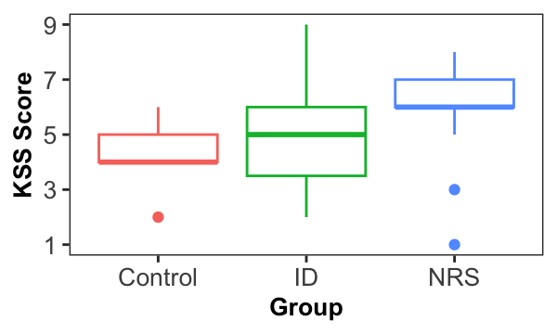
Note. Horizontal lines represent median scores, while boxes show interquartile range (IQR). Whiskers extend to 1.5 times the IQR with outliers labelled.

A post-hoc power analysis using G*power (Faul et al., 2007) determined that using a set alpha of 0.05, the study achieved a power of approximately 0.39 for the found effect size. However, as the KSS generally produces large effect sizes for differences between groups (Åkerstedt et al., 2014), this result suggests there is no significant group differences in state subjective sleepiness upon awakening.

Comparing objective sleepiness between groups
To investigate if brain activity between groups differed upon awakening, a one-way ANOVA using a cluster mass permutation analysis was conducted, with the dependent variables of SR and AAC and independent variable of group (Figure 2). There were no
significant differences between clusters before or after correcting for multiple comparisons (smallest uncorrected p^{channel} > .080, when corrected for family-wise error rate p = .711). These results indicate that there are no significant differences in mean objective drowsiness measures between groups when not controlling for subjective sleepiness.
The association between subjective and objective sleepiness across groups
To investigate if there was a difference in the association between EEG measures of drowsiness and KSS scores between groups, a general linear model with a cluster mass permutation analysis was conducted with the dependent variables of AAC, SR Eyes Open and SR Eyes Closed, and independent variables of group and KSS scores, and an interaction term of group membership by KSS score (Figure 3).
There were no significant clusters for the main effect of KSS for AAC or SR in eyes closed or eyes open condition (SR eyes closed smallest uncorrected p^{channel} = .038, when corrected for family-wise errors p^{channel} = .287; all other channels non-significant at the uncorrected level). A cluster of 5 channels in the central was identified with significant uncorrected p-values (p < .05) for the interaction between group and KSS for AAC, however after correcting for multiple comparisons was non-significant (F = 10.22, p = .164). All other interactions were non-significant at the uncorrected level. This suggests that after correction

Figure 2
Objective Sleepiness as Measured by EEG upon Awakening by Group
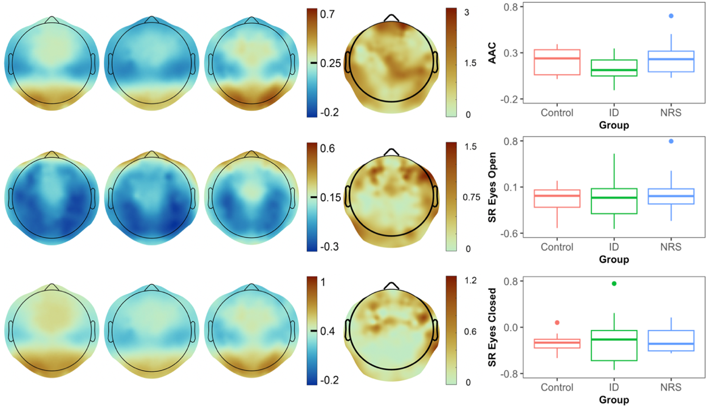
SR ECSR EOAAC
ID | NRS | Control |  | F-Test |  | Global averages

Note. Topoplots represent group average AAC and SR values. Box and whisker plots represent averaged global AAC and SR values per participant across groups. Lower (blue) AAC values represent greater sleepiness. Higher (red) SR values represent greater sleepiness.
Figure 3
KSS T-Test, Interaction F-test, Correlation Graph
KSS t-test | KSS:Group | Global average regression

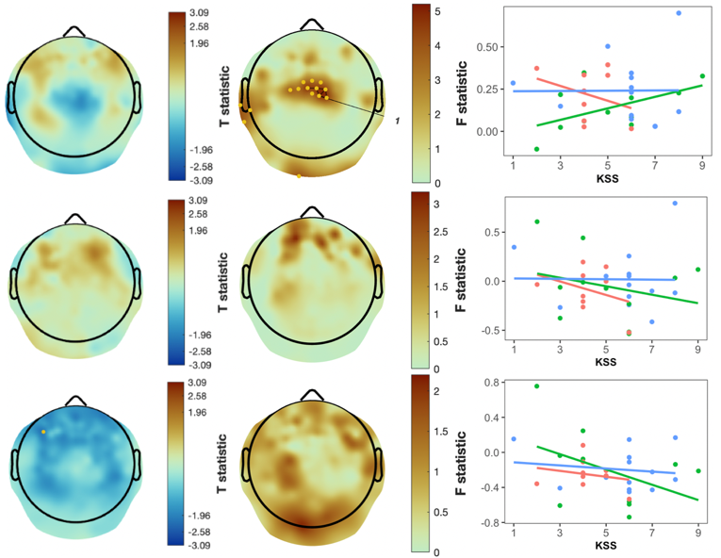
SR ECSR EOAAC
Note. Red: controls, Green: ID ; Blue: NRS.

for multiple comparisons, there was no significant effect of group membership, subjective sleepiness, or their interaction on SR or AAC.

